**Name: Stebin babu**

**Roll No:44**

**Batch:b**

**Date:21-03-2022**

**NETWORKING & SYSTEM ADMINISTRATION LAB**

**Experiment No.: 1**

**Aim**

Install the latest version of Ubuntu on an Oracle VM VirtualBox.

**Procedure**

**Step 1:** Open **VirtualBox** and click on the **New** button.

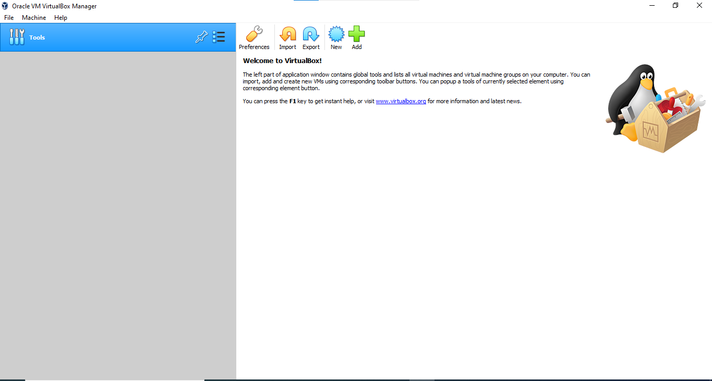

**Step 2:** Give a name to your Virtual Machine and select the location for it to install.

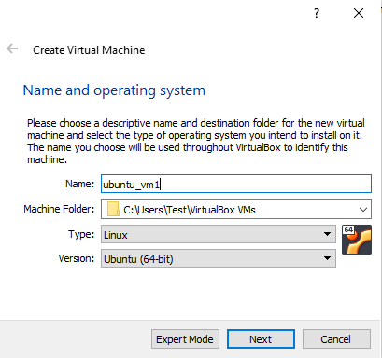

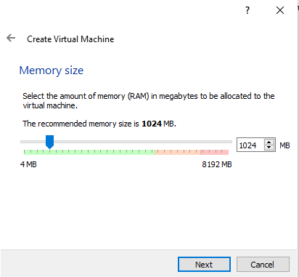**Step 3:** Assign RAM size to your Virtual Machine.

**Step 4:** Create a Virtual Hard disk for the machine to store files.

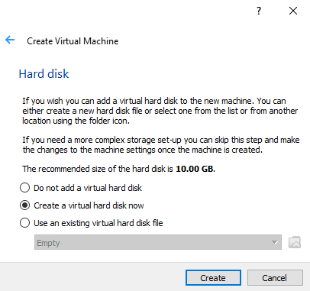

**Step 5:** Select the type of Hard disk. Using **VDI** type is recommended. Select the type of Hard disk. Using **VDI** type is recommended.

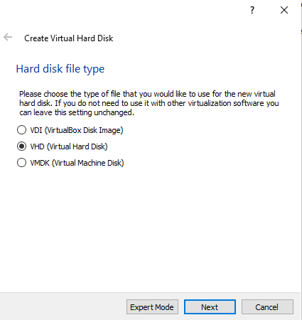

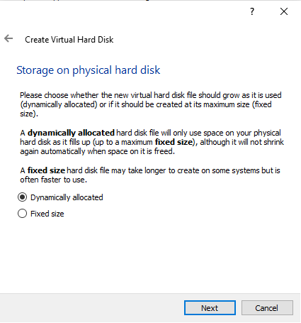**Step 6:** Either of the physical storage type can be selected. Using Dynamically allocated disk is by default recommended.

**Step 7:** Select disk size and provide the destination folder to install.

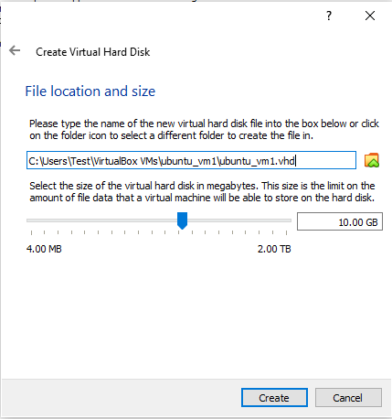

**Step 8:** After the Disk creation is done, boot the Virtual Machine and begin installing Ubuntu.

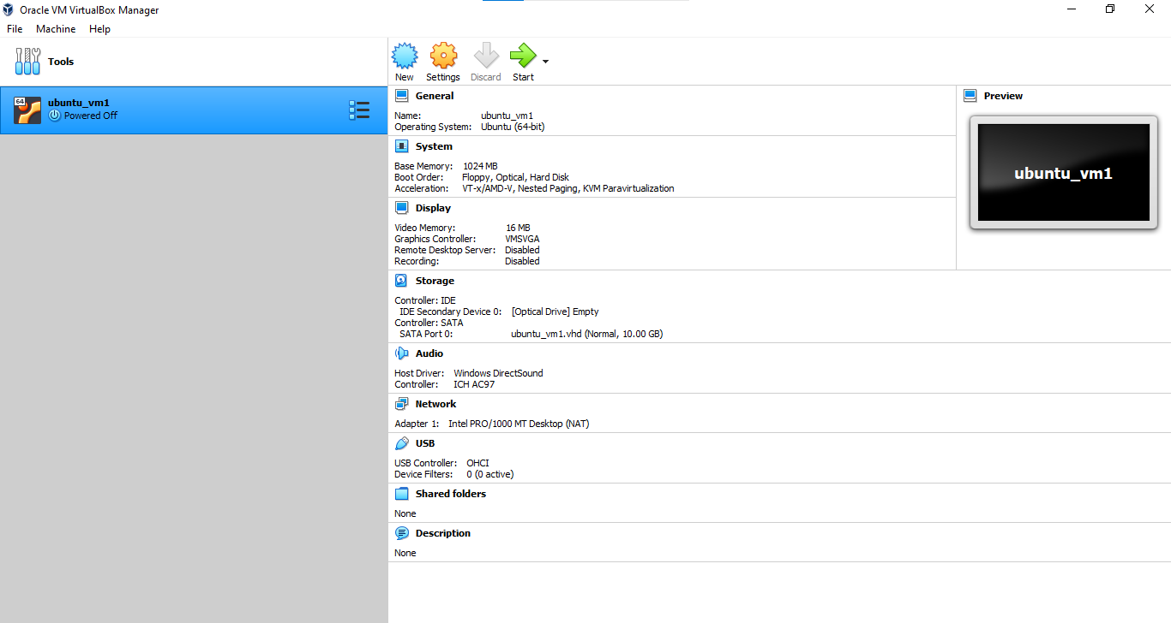

**Step 9:** If the installation disk is not automatically detected. Browse the file location and select the ISO file for Ubuntu.

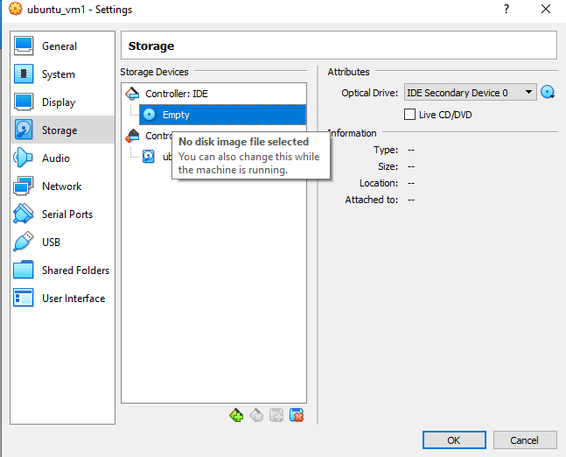

**Step 10:** Proceed with the installation file and wait for further options.

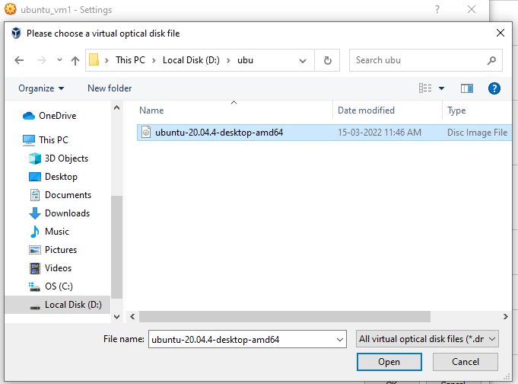

**Step 11:** Click on the Install Ubuntu option, this might look different for other Ubuntu versions.

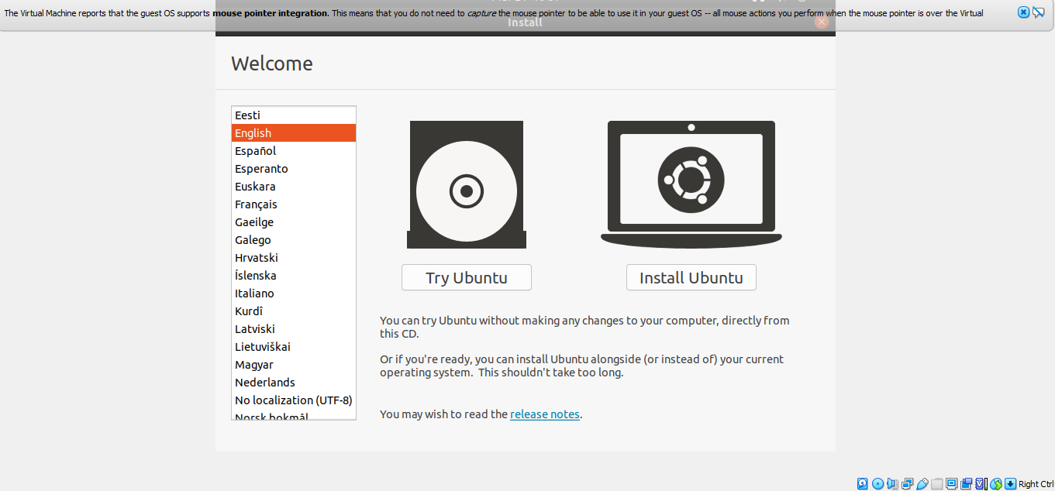

**Step 12:** Select installation type. By default, it is set to Normal installation, which is recommended, but it can also be changed to Minimal installation if there is no need for all Ubuntu features.

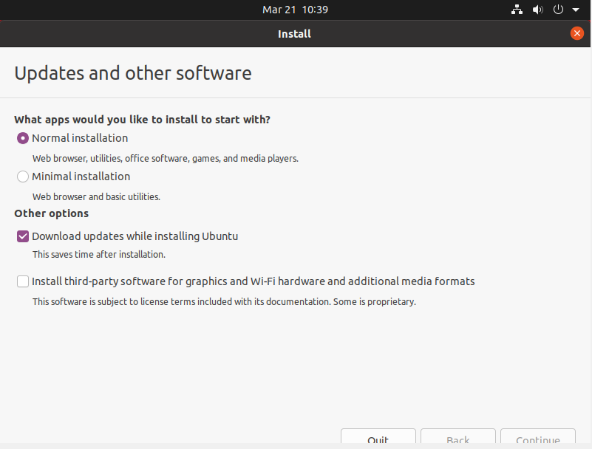

**Step 13:** Click on the **Install Now** button and carry on with the installation. Do not get worried with the **Erase disk** option, it will only be effective inside the virtual machine, other system files outside the VirtualBox remain intact click on the **continue** button, and proceed with writing changes on the disk.

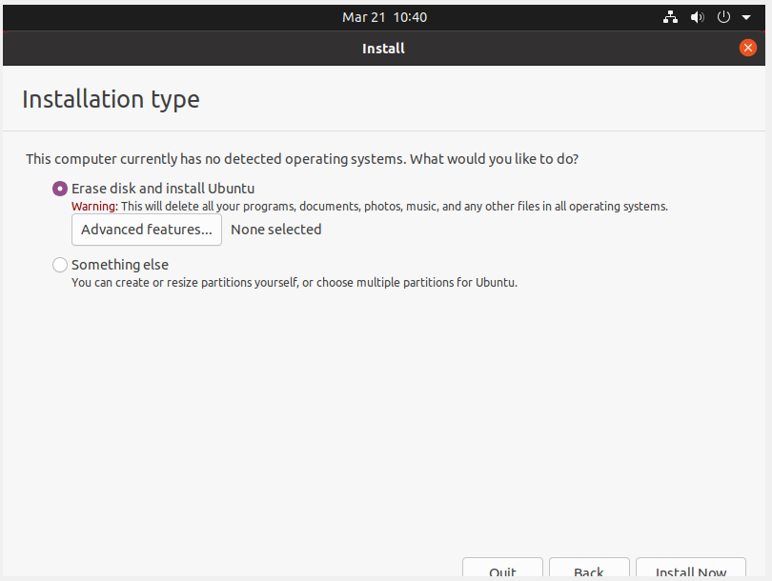

**Step 14 :** Select your location to set the Time Zone.

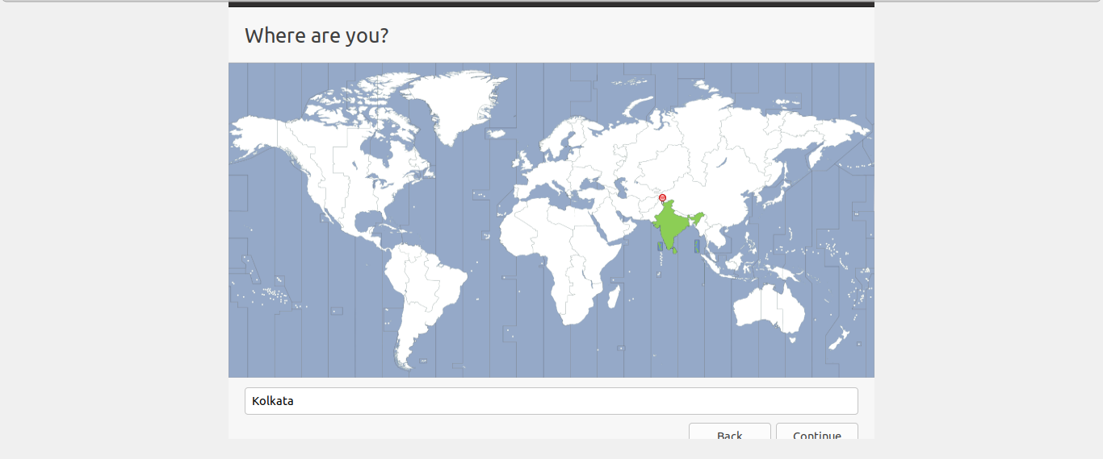

**Step 15:** Choose a name for your computer and set a password to secure login info.

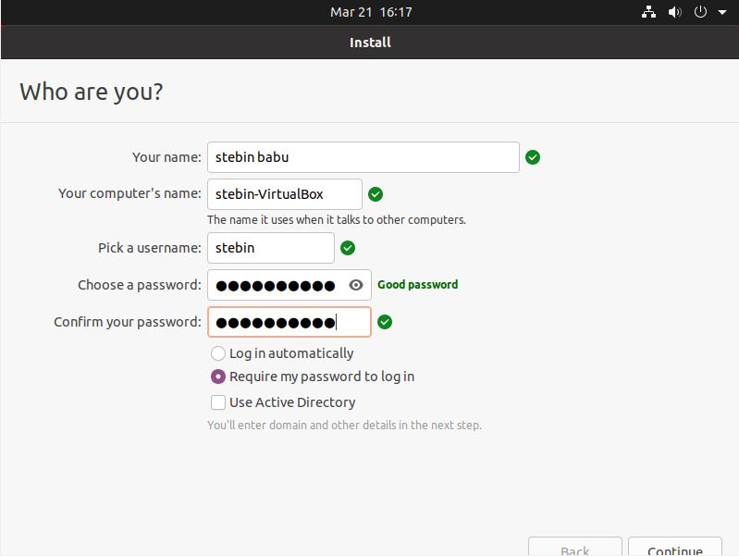

**Step 16:** Wait for the installation process to complete.

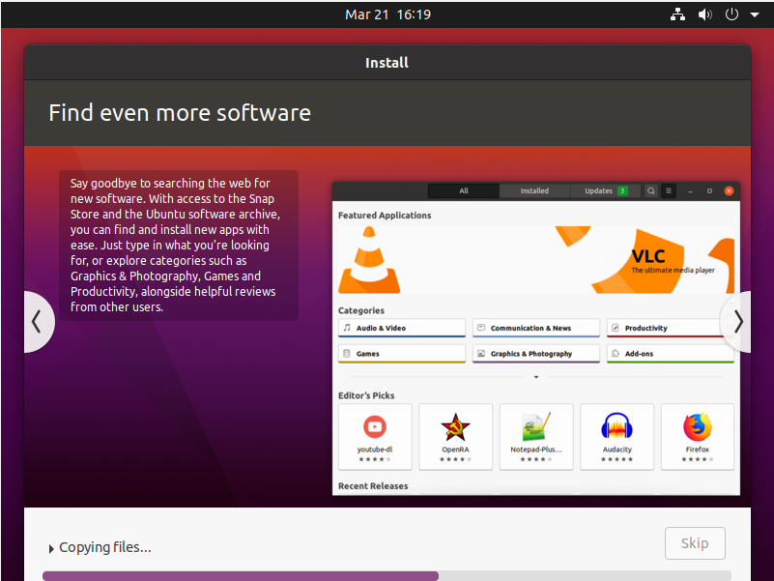

**Step 17:**  installation process finished.

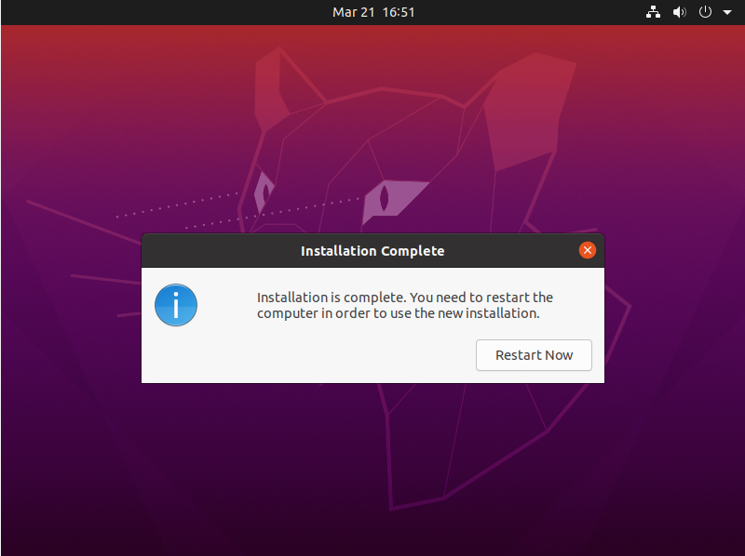

**Output Screenshot**

